Flint Rock Consulting Human Resources:
Financial Planning Model
Giovani Valladares Giron
November 14, 2025

Executive Summary
A model was initially created with stable elements to predict the increase of a retirement account over the course of 20 years. The goal of this model is to see if the retirement account could reach $1,000,000 at the end of those 20 years. The initial model only led to $807,130 at the end. A goal seek was run to see how much you would need to contribute annually to make it to $1,000,000. After that, the annual salary growth rate and portfolio growth rate were changed into variable rates that would change year after year and run on 20 and 25-year 1000-trial simulations to produce more realistic results.

20-Year Prediction Model
The initial model consisted of stable parameters, listed in the appendix, that would interact each year to create the end balance from an initial balance. When using the initial model with a stable growth rate of the portfolio and salary and a regular deposit of 6% of income, the model concluded that at the end of 20 years, the ending balance would be $807,130 dollars at the end.

With the initial goal of getting to 1,000,000 dollars at the end of those 20 years of input, a goal seek was run on the model with the changing variable being the percent of income being put into the retirement account. The conclusion of this goal seek was that 8.65% of income would have to be placed into the account per year to reach 1,000,000 at the end of 20 years.

Variability Design
After the initial model was run without variability, portfolio and annual salary growth were modified in the model to vary from year to year. The portfolio growth rate was based on a normal distribution with a mean of 9.85% and a standard deviation of 4.9%. The annual salary growth rate was based on a uniform distribution with a minimum of .02% and a maximum of 5.1%. The initial balance of the account, initial salary, and 6% yearly input into the account were left unchanged in the simulation model.

Simulation Results and Recommendations
Once the model was adjusted, 1000 trials of the simulation were run with the ending balance of 20 years being measured on each trial. This led to there only being a 3% chance of the ending balance being equal to or over 1,000,000 dollars. This was with a mean ending balance of 732,531 dollars at the end.

When seeing the result of this model, for individuals who are looking to make over 1,000,000 in their accounts, I would recommend an increased annual input into the retirement account or extending the time of the account. The goal seek in the previous example showed that increased input into the account in the long run would increase the end balance. Even with the variability of the growth rates, it would increase the chance of reaching 1,000,000 dollars at the end. The same would happen with the extended time of the account, which was seen in the 25-year simulation.

25-year Simulation
When the simulation was edited to calculate the account on a timeline of 25 years as opposed to 25 years, we saw an increase from the percentage change that the end balance was bigger than 1,000,000 from a 3% chance to an 85% chance. This, the mean ending balance at the end being $1,244,253, and a maximum outcome in the 1000 trials being $2,307,694 shows that the increase in time for the account to build wealth is a strong solution to increase the amount of money at the end.
Model Use for Other Employees
All parts of the model are built on the base parameters of initial salary, initial account balance, and percentage of salary invested, with outer factors like salary and portfolio growth rates being added in. This would make it easy for other employees to insert their base parameters to calculate their future expected ending balances. This was tested and found to work as intended. The only part that has not been translated was age, but since it is a factor that does not affect the output of the model, it should not cause any issue to ignore or remove it.

Appendix

Initial Parameters:
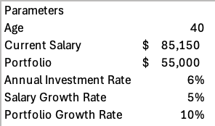

Initial 20 Year Ending Balance Graph
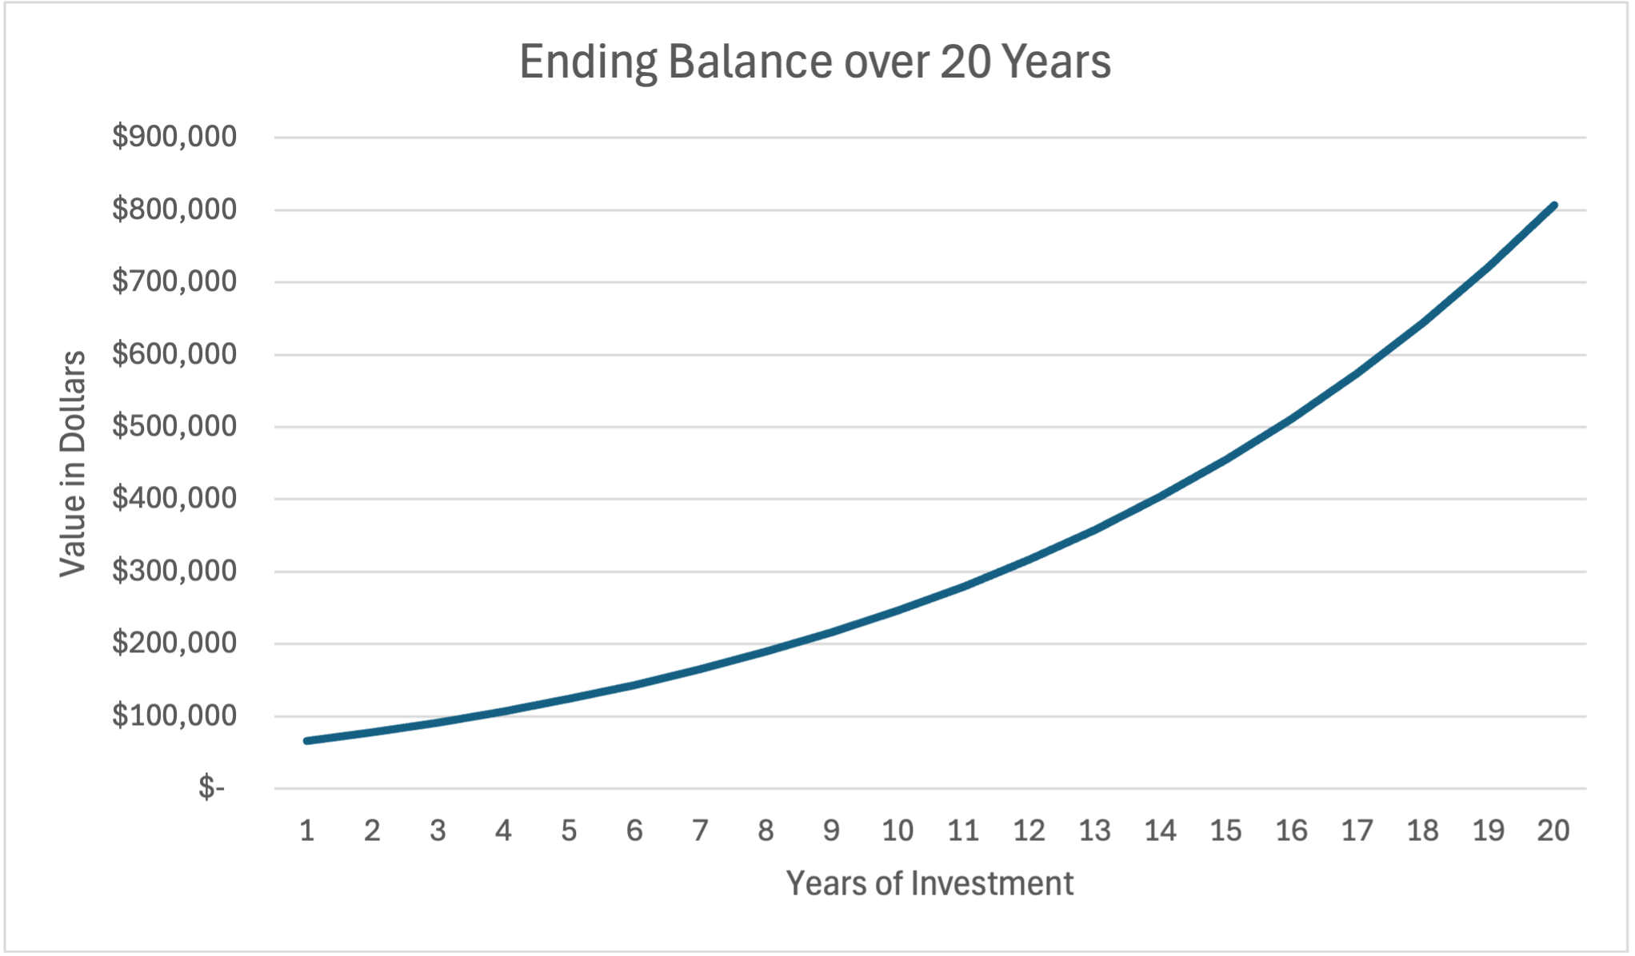
This is the balance at the end of each year, graphed. The ending balance is built up of the past year's balance, the amount input into the account that year, and the amount it earned in that year.

Goal Seek 20-year graph:
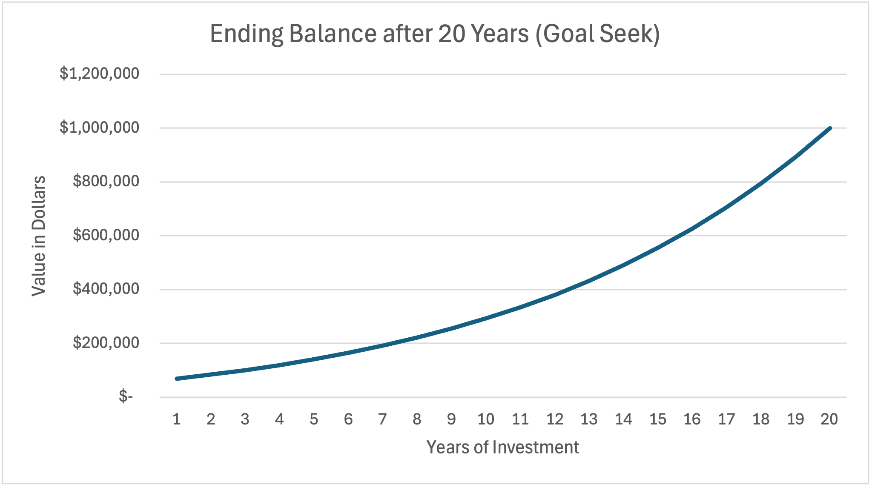

Simulation Parameters:
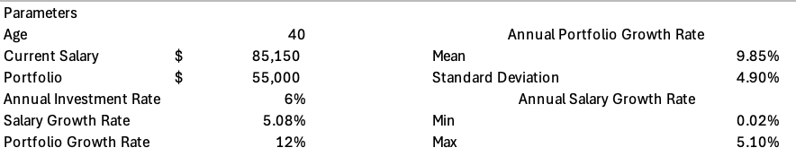

20-Year Simulation Summary Statistics and Confidence Intervals:
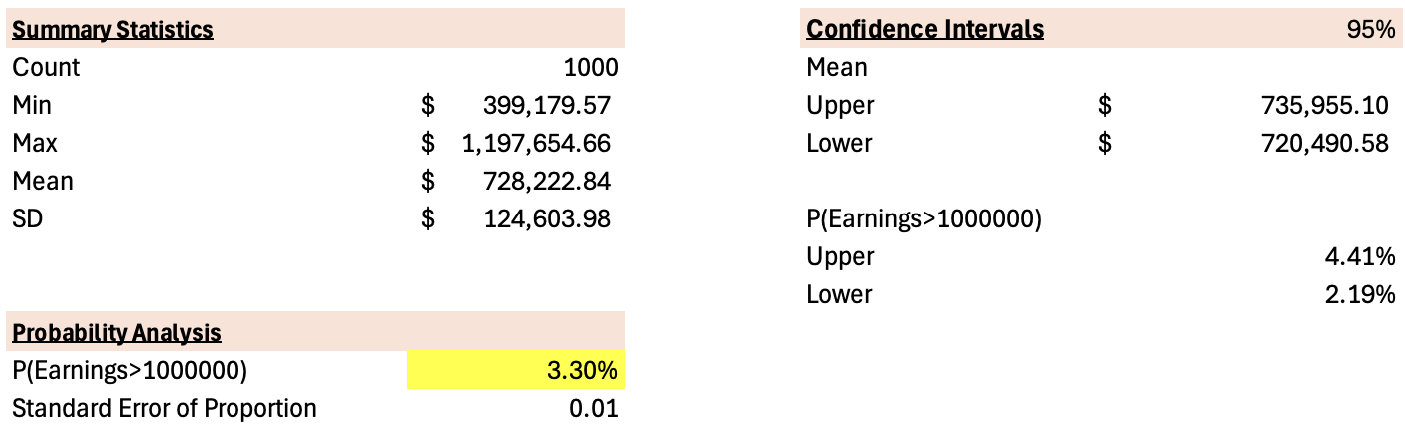

25-Year Simulation Summary Statistics


